

**Introduction to Machine learning**

**Project Phase 2**

**Team 8**

|  |  |
| --- | --- |
| Name | ID |
| AbdulRaouf Monir Kamal Mahmoud | 19P4442 |
| Abdallah Amin Fahmy | 20p5880 |
| Michael Joseph Adeeb | 1901075 |

**Submission Date: 30/12/2023**

**Submitted to: Prof. Dr. Mahmoud Khalil**

**Eng. Omar Elessawy**

**Decision Trees**

**Steps on how to run project**

1. Open Decision tree.ipynb and then run the first cell to import all the required libraries
2. Project is ready to run!

**Screenshots of the Code including the output**

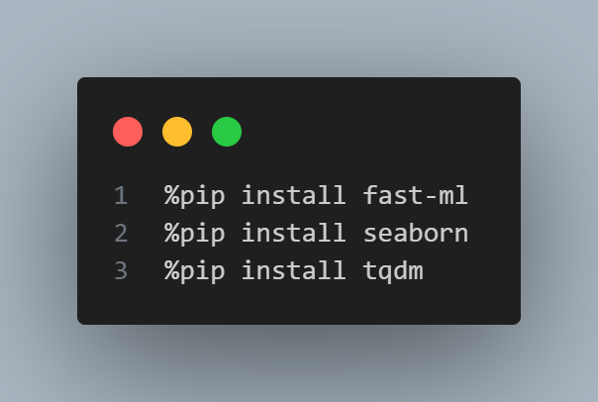

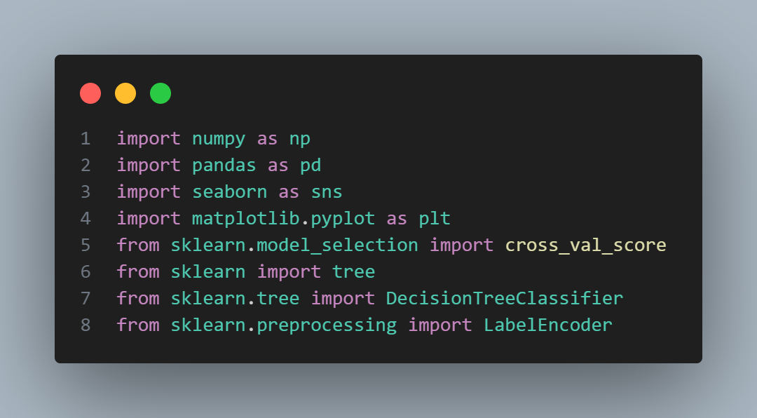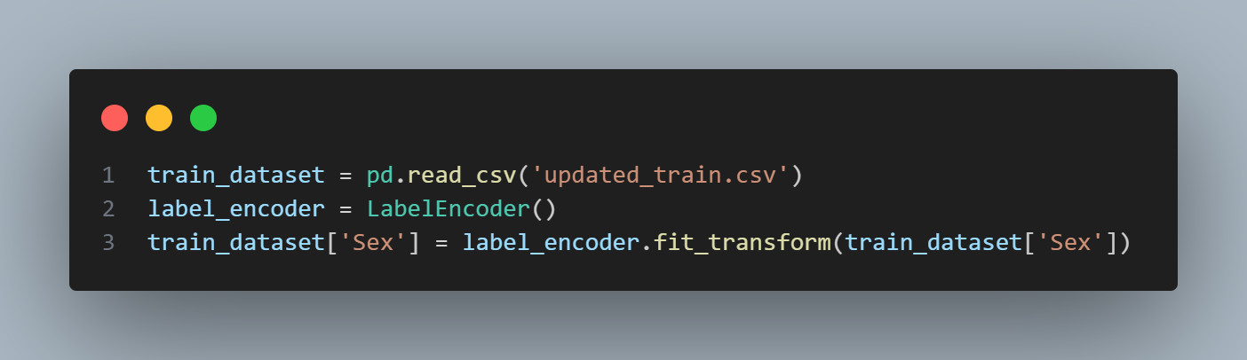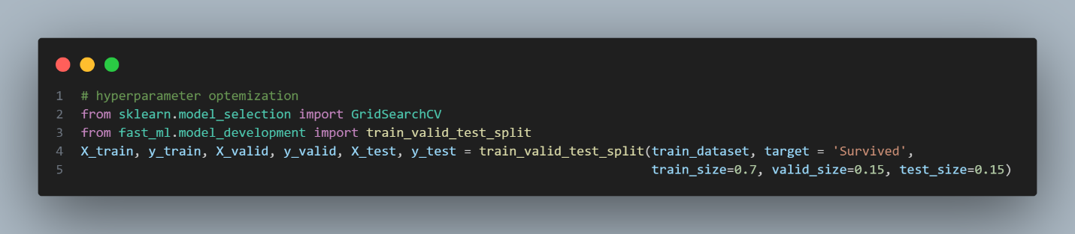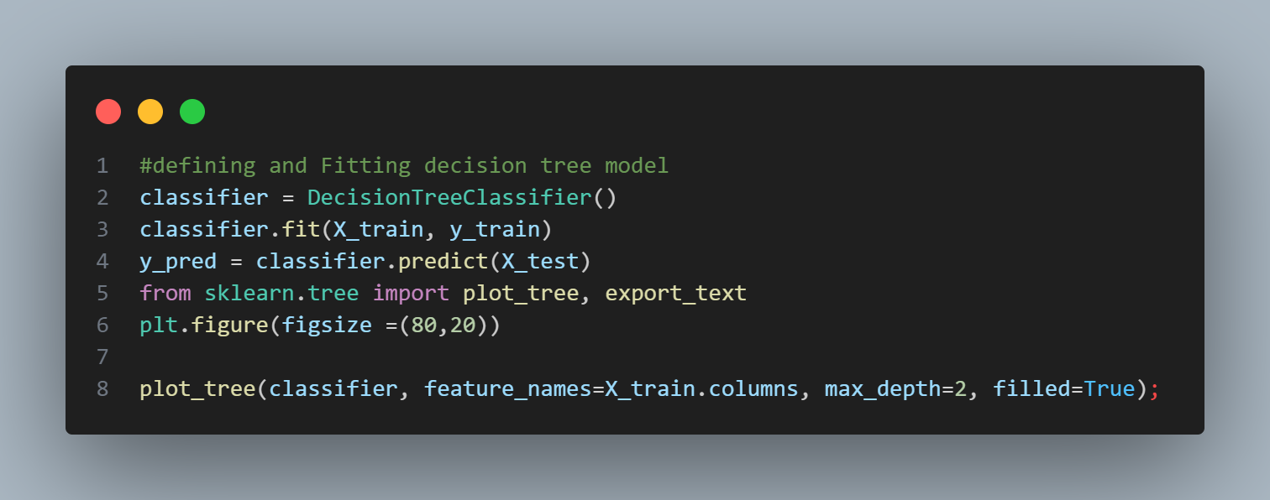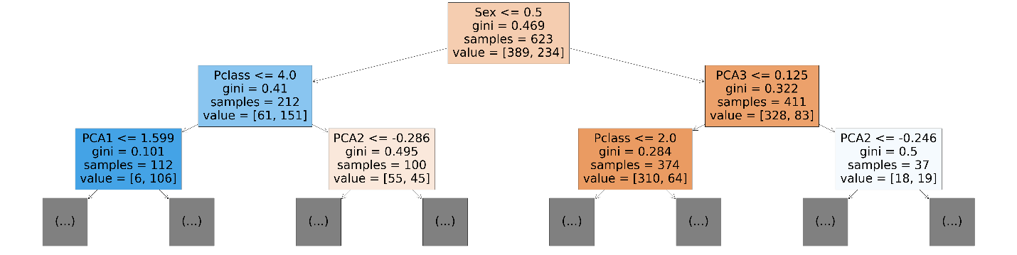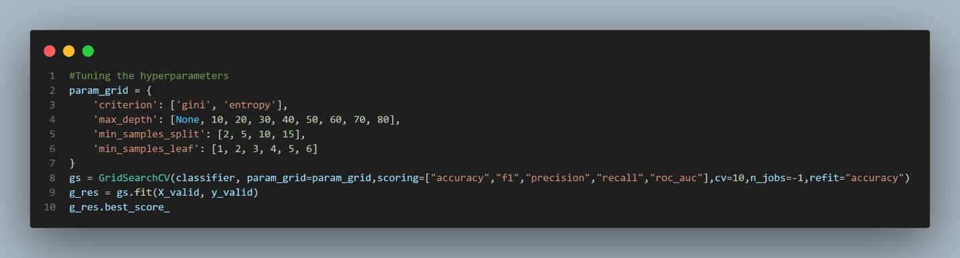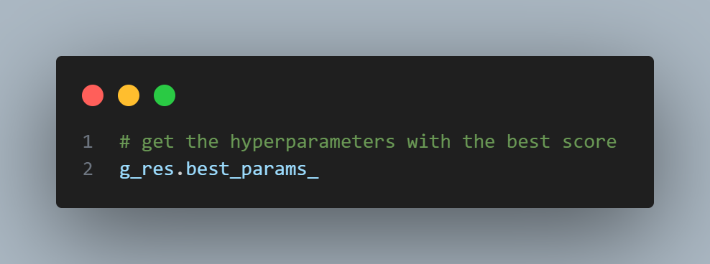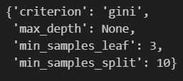

These are the optimal hyperparameters for the Decision tree classifier

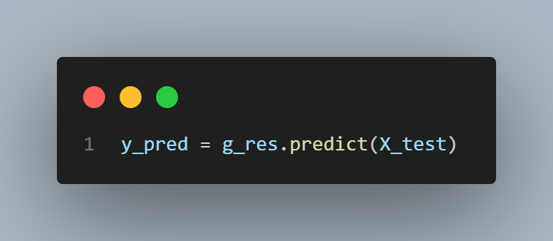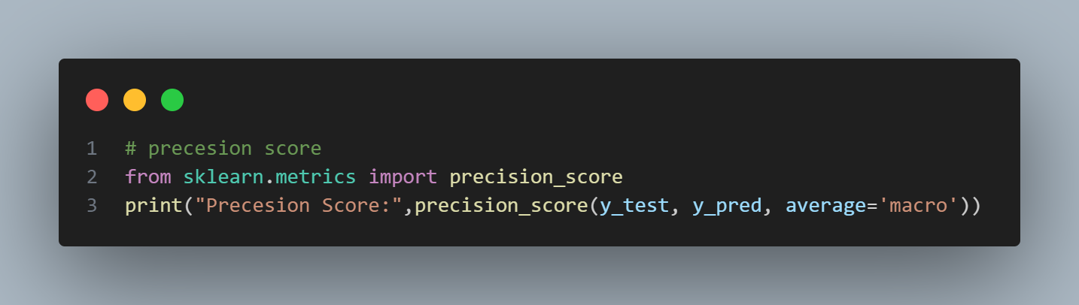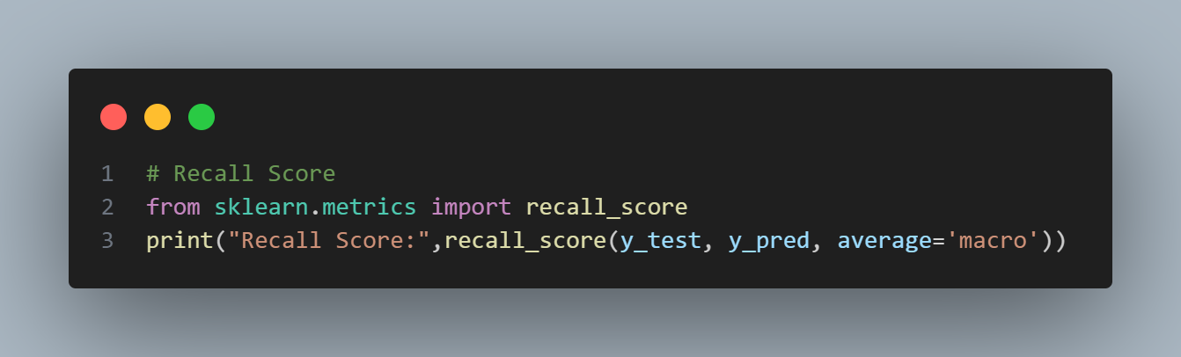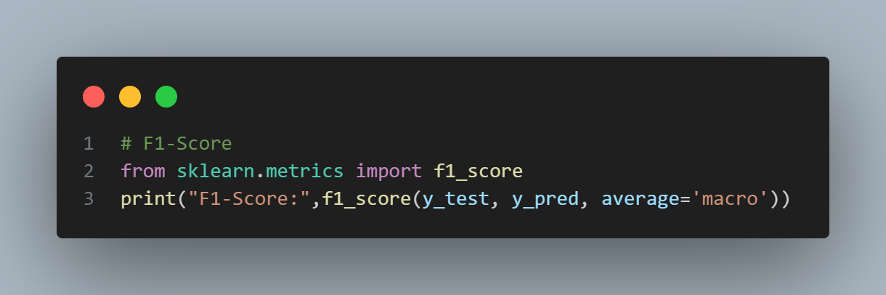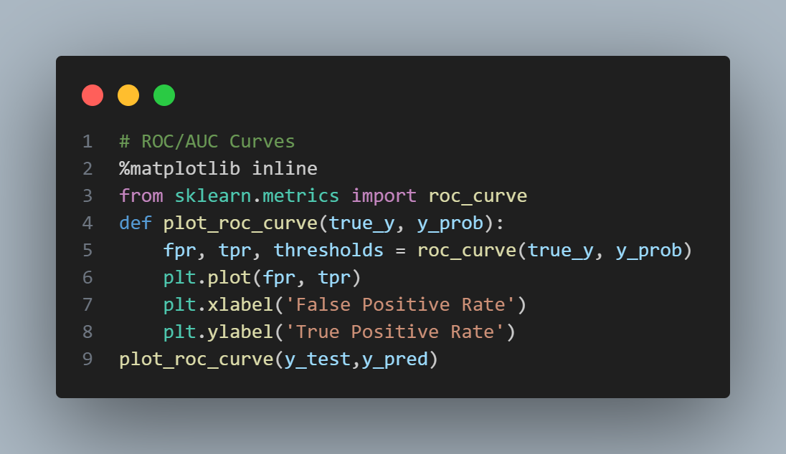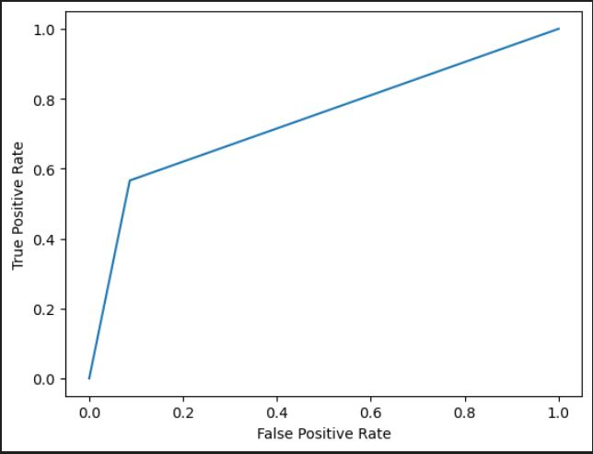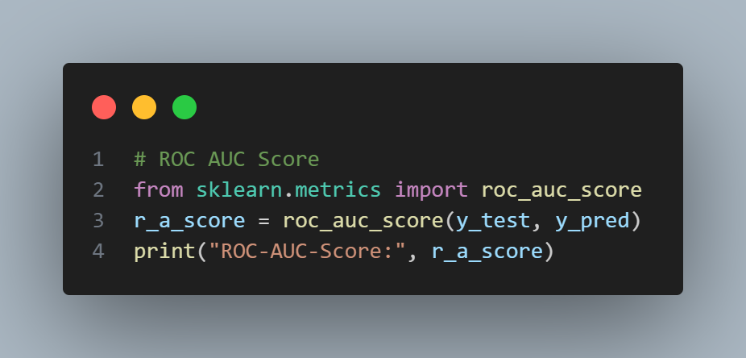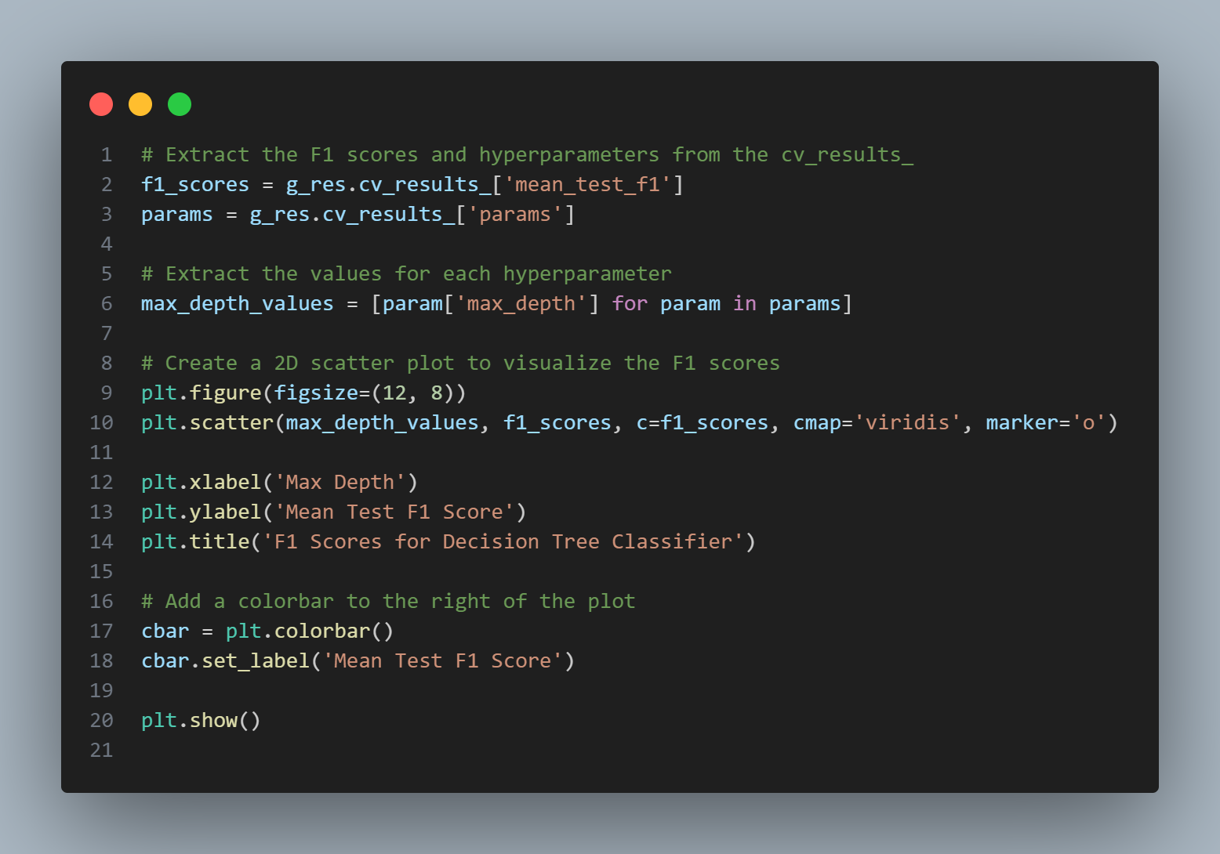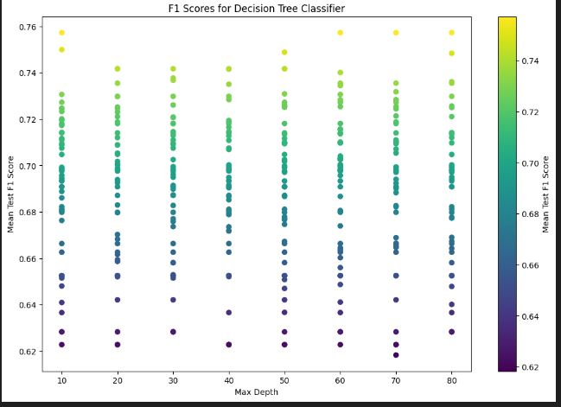

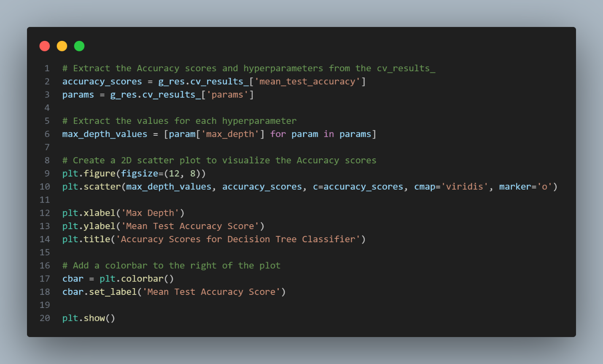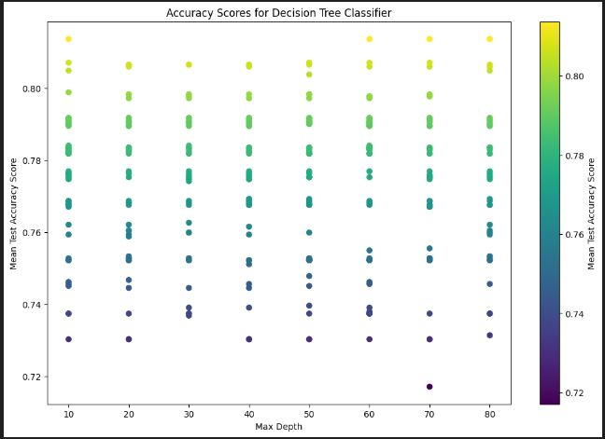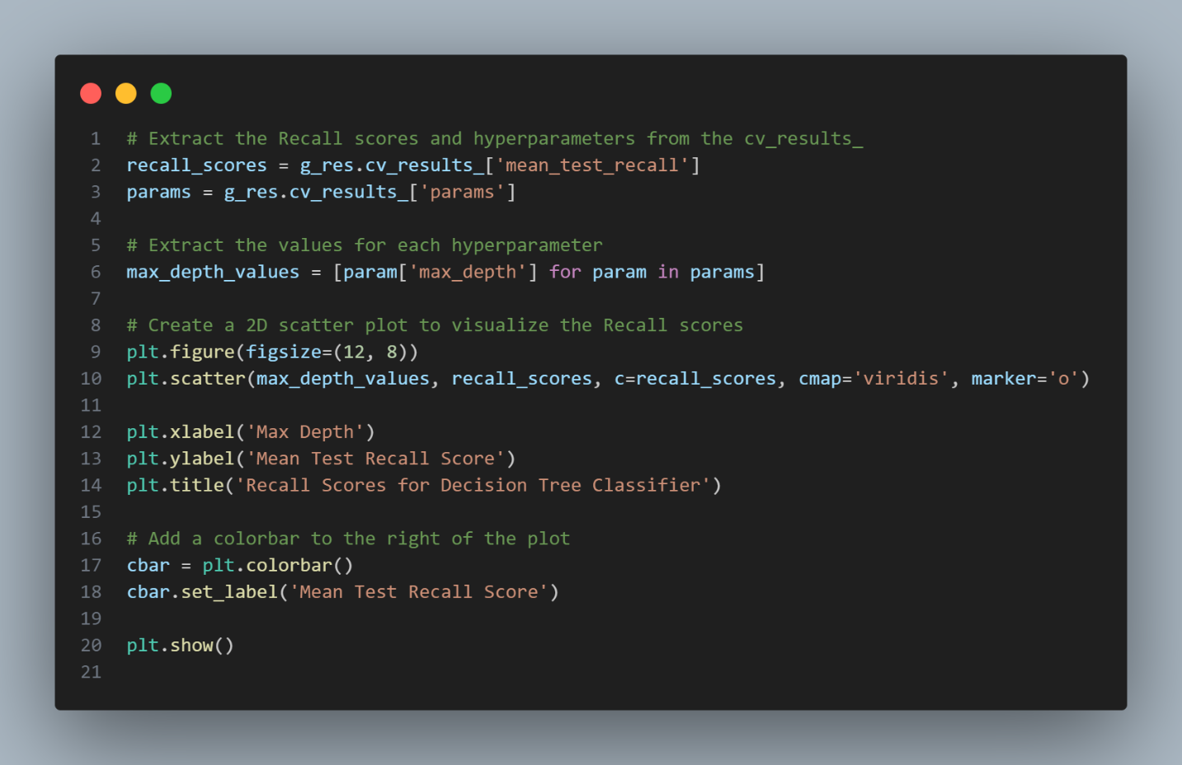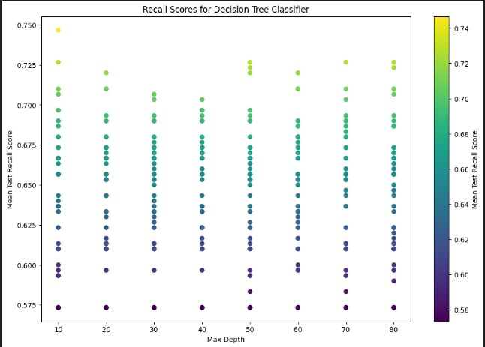

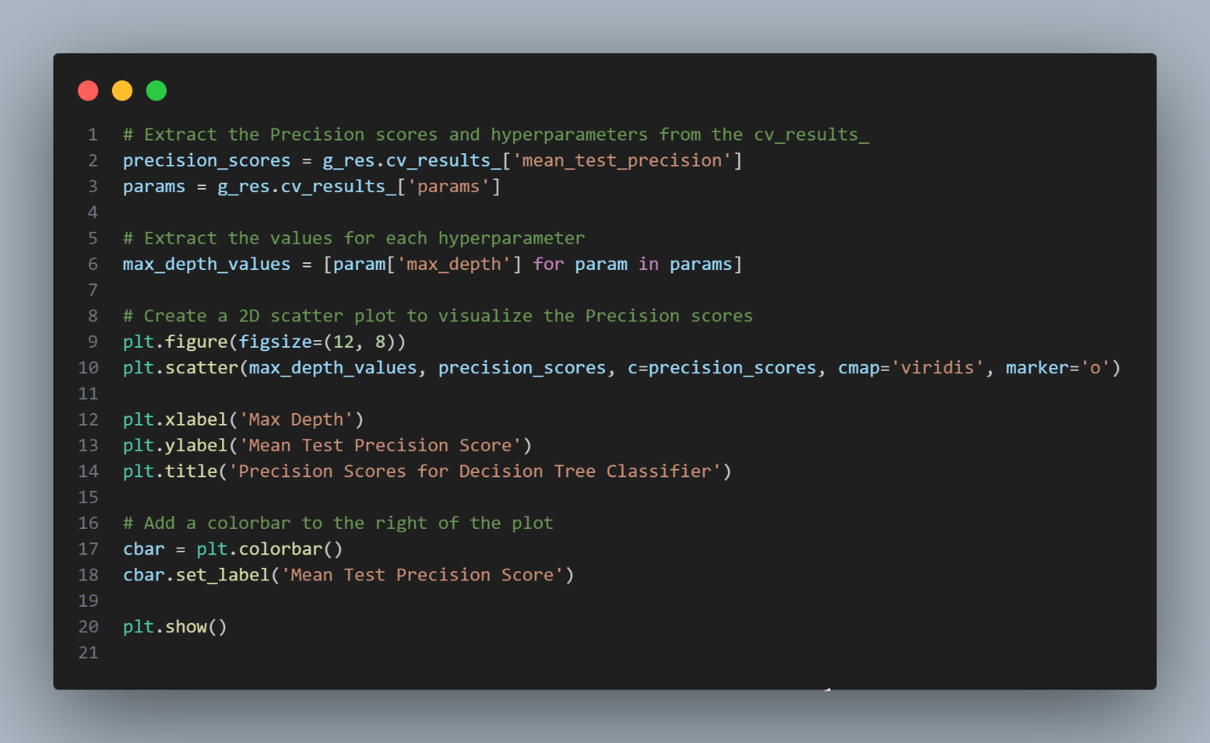

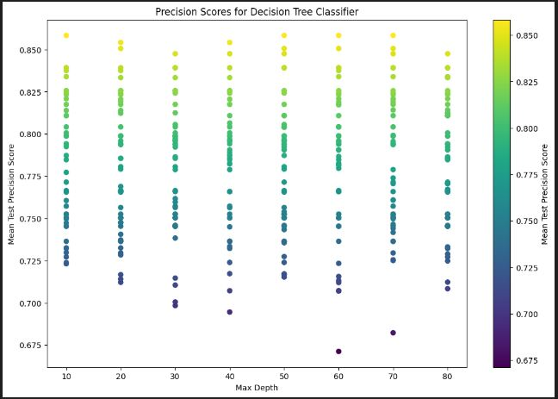

**Multilayer Perceptron**

**Steps on how to run project**

1. Open Multilayer-Perceptron.ipynb and then run the first cell to import all the required libraries
2. Project is ready to run!

**Code Screenshots and Details**

%pip install fast-ml

%pip install scikit-learn

%pip install numpy

%pip install pandas

%pip install seaborn

First, we install all the required libraries for initializing and training our multilayer perceptron model.

import pandas as pd

from sklearn.preprocessing import LabelEncoder

train_dataset = pd.read_csv('../updated_train.csv')

label_encoder = LabelEncoder()

train_dataset['Sex'] = label_encoder.fit_transform(train_dataset['Sex'])

X  = train_dataset.drop("Survived",*axis*=1)

y = train_dataset["Survived"]

Then we import our preprocessed dataset and encode the “Sex” Column as Multilayer perceptron only accepts numerical features. Afterwards, we split the data into input features (X) and the output (y)

from sklearn.model_selection import train_test_split

X_train, X_test, y_train, y_test = train_test_split(X,y,*train_size*=0.85,*test_size*=0.15)

Then we split the input and output features into training and testing sets, but this time we won’t use the fast-ml library, as there is no need to create a validation set, which we will see as progress on, will be generated by the multilayer perceptron model via the validation_factor parameter.

def generate_hidden_layer_sizes(*num_sizes*, *min_nodes*, *max_nodes*):

    return [(np.random.randint(*min_nodes*, *max_nodes*),) for _ in range(*num_sizes*)]

This is a method we will use to generate a list of different hidden_layer_sizes ( the number of hidden nodes per layer ) that will be supplied to GridSearchCV to determine the optimal hyperparameter as per the supplied parameter grid.

import numpy as np

num_hidden_sizes = 10

min_nodes_per_layer = 50

max_nodes_per_layer = 250

hidden_layer_sizes = generate_hidden_layer_sizes(num_hidden_sizes, min_nodes_per_layer, max_nodes_per_layer)

Now, we will call the generate_hidden_layer_sizes method to generate different hidden layer sizes as described above

from sklearn.neural_network import MLPClassifier

from sklearn.model_selection import GridSearchCV

param_grid = {

    "activation": ["identity","logistic","tanh","relu",],

    "solver": ["lbfgs","sgd","adam",],

    "learning_rate": ["constant","invscaling","adaptive",],

    "early_stopping": [True, False,],

    "validation_fraction": [0.15,],

    "hidden_layer_sizes": hidden_layer_sizes

}

mlp = GridSearchCV(

    MLPClassifier(),

*param_grid*=param_grid,

*scoring*=["accuracy","f1","precision","recall","roc_auc"],

*n_jobs*=-1,

*cv*=2,

*refit*="f1",

*verbose*=True

      )

mlp.fit(X_train,y_train)

mlp.best_score_

Finally, we will call the GridSearchCV object to supply it with a multilayer perceptron object, and parameter grid that act our hyperparameters with almost each and every possible value of each hyperparameter, and only two folds for simplicity, and the refit is going to be based primarily on F1-score

Then we will print our best achieved score, which is approximately 75%



y_pred = mlp.predict(X_test)

In this line of code, we just create a variable that will be used for calculating precision, recall, f1-score, and roc/auc measures

import matplotlib.pyplot as plt

from sklearn.metrics import roc_curve

def plot_roc_curve(*true_y*, *y_prob*):

    fpr, tpr, thresholds = roc_curve(*true_y*, *y_prob*)

    plt.plot(fpr, tpr)

    plt.xlabel('False Positive Rate')

    plt.ylabel('True Positive Rate')

Above is a function to plot roc/auc curve

from sklearn.metrics import roc_auc_score

plot_roc_curve(y_test, y_pred)

plt.show()

print(f'Multilayer perceptron AUC score: {roc_auc_score(y_test, y_pred)}')



import matplotlib.pyplot as plt

iterations = [i for i in range(1,mlp.best_estimator_.n_iter_+1)]

loss_curve = mlp.best_estimator_.loss_curve_

plt.plot(iterations,loss_curve)

plt.xlabel("Iteration Number")

plt.ylabel("Loss Function")

plt.title("Loss Curve")

This is a function to visualize the loss curve of our best estimator(model)

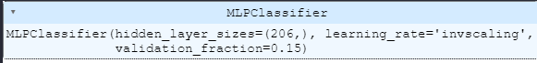

These are the properties of the best estimator as per the parameters in parameter grid, and are the **optimal hyperparameters**

Now we will visualize the fit against accuracy metric (precision, recall, f1-score, and roc/auc)

fits = [fit for fit in range(1,73)]

accuracy = mlp.cv_results_["mean_test_precision"][::10]

plt.plot(fits,accuracy)

plt.xlabel("Fit")

plt.ylabel("Precision")

plt.title("Precision")

The code is similar for all other accuracy change metrics, note that many of the fits have been removed for better visualization of the accuracy change

